## Mixed Convection in an Empty Room with a Box

To further simulate a more realistic situation, this case puts a rectangular box inside the center of the room to mimic heat source in a real room, like occupants. This case is same with the Case B from (Wang and Chen 2009) The room is 2.44m in length, width and height and the box has dimensions of 1.22m × 1.22m × 1.22m as shown in *Figure 1*. The inlet is located on the west wall with height of 0.03m and the outlet on the east wall with height of 0.08m. The velocity and temperature of inlet flow are 0.455 m/s and 22.2 *oC,* respectively. The temperature is 25.8 *oC* on the ceiling, 26.9 *oC* on the floor and 27.4 *oC* on other walls of the room. The temperature on the surface of the box is 36.7 *oC.* Finally, a non-uniform 20 × 20 × 20 mesh was used and the time step size of the FFD simulation was 0.1 seconds. The data synchronization step size and simulation time was 6 seconds and 180 seconds, respectively. The CPU time of the coupled simulation was about 268 seconds.



*Figure 1 Schematic of mixed convection in an empty room with a box (XZ-plane).*

Figure 2 shows the velocity vectors and temperature contours on the cross-section at the center of the room computed by FFD. There are two weak circulations formed at the upper part of the figure due to the combined function of inertial force and buoyance force. The upper part is highly non-uniform due to the strong buoyance force while others parts have relatively uniform temperature distribution. *Figure 3* shows data plotting from Modelica. Two sensors are set at (1.22m, 1.22m, 1.5m) to extract the velocity and temperature. The results show that temperature at sensor location increases gradually to about 27.3 *oC* until the flow are fully developed. Velocity at the sensor location oscillating frequently indicates the flow is sensitive and unsteady. The heat

flow through the heat port of ceiling changes gradually from negative to positive because at the beginning the room temperature is lower and later higher than the temperature of air near the ceiling due to the heating of the box. For other walls the heat flow is relatively small due to the small temperature difference.

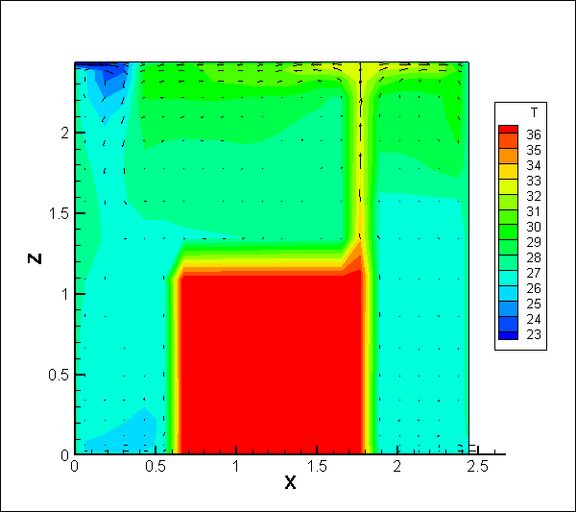

*Figure 2 Velocity vectors and temperature contour of the mixed convection on a cross-section at y=0.5m computed by FFD*



*Figure 3 Temperature and air velocity at sensor location, heat flow rates through the heat ports of the heat sources that connect to the walls*

Wang, M. and Q. Chen (2009). "Assessment of various turbulence models for transitional flows in an enclosed environment (RP-1271)." HVAC&R Research **15**(6): 1099-1119.